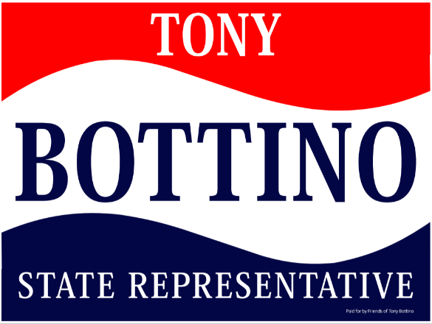

CAMPAIGN DONOR FORM

Enclosed contribution: $ ______________________________

Please make checks payable to Friends of Tony Bottino and mail to:

442 West Main Street, Suite 202 | Monongahela, PA 15063

For further information contact – TonyBottino49@gmail.com

DONOR INFORMATION

Name: | _______________________________________________________________________
Address: | _______________________________________________________________________
City/State/Zip: | _______________________________________________________________________
Phone: | _______________________________________________________________________
Email: | _______________________________________________________________________
Employer: | _______________________________________________________________________
Occupation: | _______________________________________________________________________
Business address: | _______________________________________________________________________
City/State/Zip: | _______________________________________________________________________

Corporate contributions are prohibited by Pennsylvania Election Law. Political contributions are not deductible for income tax purposes. The Friends of Tony Bottino committee may accept unlimited personal, partnership, sole proprietorship or PAC donations. Pennsylvania Election Law requires political committees to report the name, mailing address, occupation and employer for each individual whose contributions aggregate in access of $250 per reporting period.

